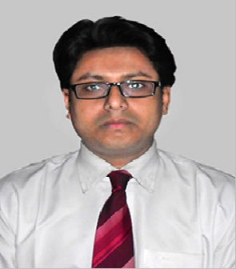

**Md. Atiur Rahman**

40/1 Lalmohon shah street, Dholaikhal, Wari, Dhaka-1203

Cell: +8801626626862, +8801976626862

Email: atiurrahman.ctg@gmail.com

**Career Objective:**

To achieve the best and make a dynamic career for myself and serving community by working

With dedication, sincerity, loyalty commitment, in a creative and open environment.

**Education:**

**Program : MBA** (Major in Human Resource Management)

Result : 3.13 (in the scale of 4)

University : World University of Bangladesh

Year of Passing : 2017

**Program : BBA** (Major in Marketing)

Result : 2.87 (in the scale of 4)

University : World University of Bangladesh

Year of Passing : 2014

**Higher Secondary Certificate (H.S.C):**

Concentrated Area : **Business Studies**

Result : 3.10 (in the scale of 5)

Board : Dhaka

Institute : Shaikh Burhanuddin College

Year of Passing : 2010

**Secondary School Certificate (S.S.C):**

Concentrated Area : **Business Studies**

Result : 3.38 (in the scale of 5)

Board : Dhaka

Institute : Nawabpur Govt. High School

Year of Passing : 2008

**Computer Knowledge:**

* Operating System :All edition of Windows, Mac osX, Linux and Adroid
* Application Package : Ms Office 2007-2013 (Word, Excel, Power Point, Outlook-mail)
* Other : Have working ability with e-mail and Internet browsing.

**Language Proficiency:**

* Bangla : Mother Language.
* English : Good command on Spoken and written English

**Working Experience:**

* **Search-Light Events & Marketing Ltd.**

***Event: Nido Festival, Grameenphone package migration event.***

(As a brand promoter 2012-2014)

* **Market Express Ltd.**

***Service provider for Unilever Bangladesh Ltd.***

(As an HR Coordinator 2015-2017)

* **Salvo Chemical Industry Ltd.**

(As a Store Manager 2018-2019)

* **Fair Electronics Ltd.**

***Sales Executive for Samsung Smart Plaza***

(As a Retail Sales Executive January 2020 to Running)

**Personal Profile:**

Father’s Name : Md. Lutfar Rahman

Mother’s Name :Afroja Rahman

Permanent Address : Village: Baoikhola, Post: Tenguria para, Dist: Tangail

Date of Birth : 30 December 1992

Marital Status : Single

Nationality : Bangladeshi (By Born)

Religion : Islam (Sunni)

Blood Group : O+ (Positive)

|  |  |  |
| --- | --- | --- |
| **Reference** |  | ***Md. Shahidul Haq*** |
|  |  | *Deputy General Manager*  *Janata Bank Limited*  *Foreign Exchange Corporate Branch, Dhaka*  *Cell: 01711421841* |
|  |  | ***Md. Azizul Huque*** |
|  |  | *Manager (Foreign Exchange)*  *Janata Bank Limited*  *Nawabpur Road Corporate Branch, Dhaka*  *Cell: 01712503823* |

­